Kwasizabantu – the place where people are helped
A mission housing a radio station, school, teaching college, pasta factory, bakery, dairy, counselling centre, hospice and more.

July 23, 2014
Author: Jodi van Wyk

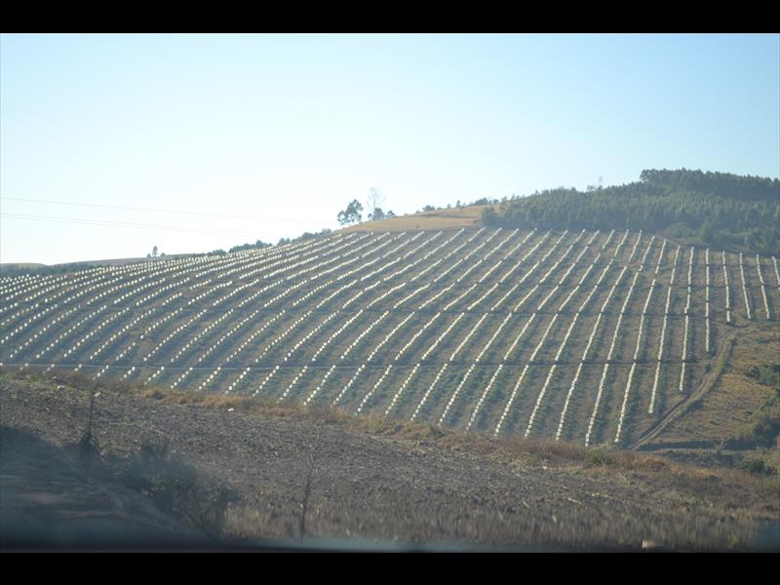
The baby avocado trees are protected with plastic bags.

Kwasizabantu – the place where people are helped.
The name of a farm just 60km out of Stanger could not be more apt for its function.
Kwasizabantu mission was established in 1970 by Reverend Erlo Stegen, after he and his brother purchased a 140ha farm from the Maharaj family.
Today, still under the directorship of Reverend Stegen the sprawling 540ha mission is home to an award-winning radio station, school, teaching college, pasta factory, bakery, dairy, counselling centre, hospice, 10 000-seater amphitheatre, coffee shop and farms that yield rich harvests of peppers and avocados.
Recognised bottled water brand aQuellé is also manufactured at the mission, situated in Kranskop, Maphumulo, 60km inland from Stanger.
The dairy produces Bonlé yoghurt, another well-known brand, while peppers are supplied to big names like Woolworths and Spar.
Mouth watering croissants, pretzel rolls and jam tartlets are churned out of the bakery from as early as 4am every morning and supplied to a Save Rite store on the mission's border.
Cedar College students and pupils of Domino Servite school study without the hustle and bustle of the city, with giant avocado trees for shade.
The Courier was given a guided tour by Kjell Olsen, who has lived on the mission for almost two decades.
“We have never asked for donations or done collections because our projects sustain us. But the mission is not only a special place because of all the projects – it is special because of our people.”
Kwasizabantu employs 150 permanent staff members in its projects, some of whom have come through the mission's drug rehabilitation programme.
“We help hundreds of recovering drug addicts daily. This is a place where people come for spiritual help and healing. Those who need help are put through a three-week programme and some stay on as volunteers for the mission.”
The addicts are helped through their addiction by the Concerned Young People of South Africa (CYPSA), housed at Kwasizabantu.
“We focus on the issue that caused the addiction. Often, an addict will relapse because the thing that pushed them towards drugs was never resolved. Here, their accommodation and meals are free provided they attend meetings and commit to recovery,” said CYPSA's Adam Mickelburgh.
Addicts who have not completed their schooling or want to further their studies can do so at the mission.
More than 200 people from surrounding areas like Kranskop and outer Maphumulo volunteer at the mission. Students from across the country and even overseas spend their gap years volunteering at the dairy or bakery.
The amphitheatre, which Olsen calls “Noah's ark, upside down”, was built by volunteers.
Radio Khwezi also boasts a recording studio, which has recorded the likes of the Drakensburg Boys' Choir.
“At Kwasizabantu we do exactly what our name suggests – we help. Anyone who wants to visit is most welcome to.”
If you would like to find out more about the mission visit www.ksb.org.za.
For more information on CYPSA visit www.preciousyouth.co.za.
Volunteers knead out raisin bread.
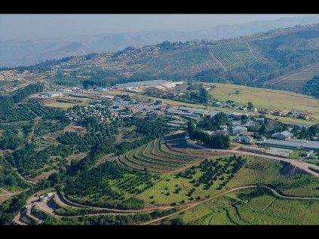
The expansive 540ha plot, surrounded by farms. Photo: Daniel Wonderlink.
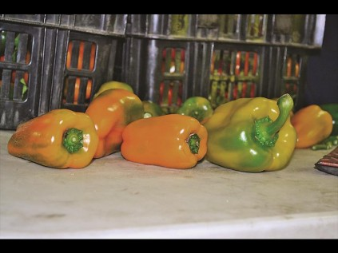
Orange peppers, who knew!
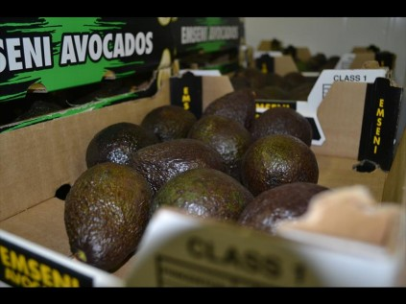
A box of avos ready for transport.
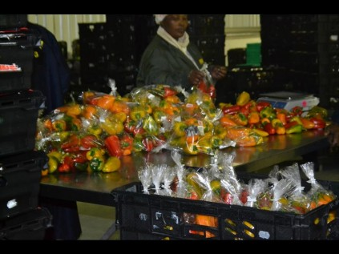
Colourful peppers packaged for Woolworths.
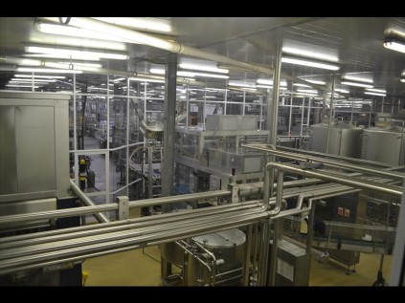
Inside the aQuelle factory.
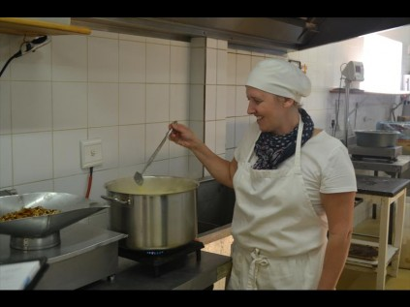
Lisa Engelbrecht in the bakery, preparing a pecan pie.
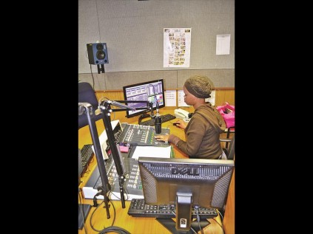
Radio Khwezi DJ Mbali Mthethwa during a broadcast.
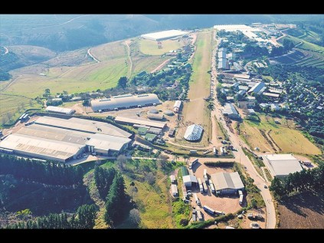
An aerial shot of the mission. Photo: Daniel Wonderlink.
INSET: Shelves of croissants, baguettes, breadrolls, breads and cakes from the bakery, ready for sale.
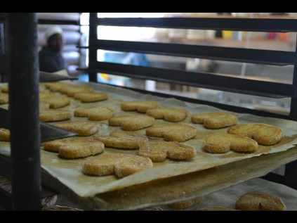
Yummy confectionaries ready for the shelf.
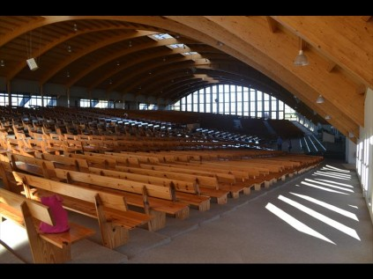
Inside the 10 000 seater amphitheatre, which houses kilometres of pews.
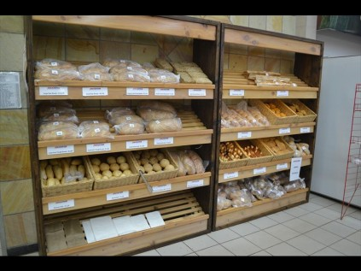
Products of the mission’s bakery include breads, rolls and croissants.

19114

